

Marking and Feedback Policy
Reviewed: July 2024
To be reviewed: September 2026

Introduction

At The Pioneer Academy (TPA) we strive to support all pupils to achieve to their highest potential. It is essential to show pupils that every piece of work they produce is valued and respected. By giving regular feedback to pupils with consistency, and providing positive praise and points for development, we aim to raise not only their attainment, but also their self-esteem.

Aims

- To ensure feedback has a positive impact on pupil learning.
- To ensure that feedback given is consistent across our schools and provides development points for pupils to help raise attainment.
- To ensure that feedback is given in a way and at a time to inform improvements in learning within lessons and future planning.

Effective feedback provides information to learners about their performance and how to improve it.

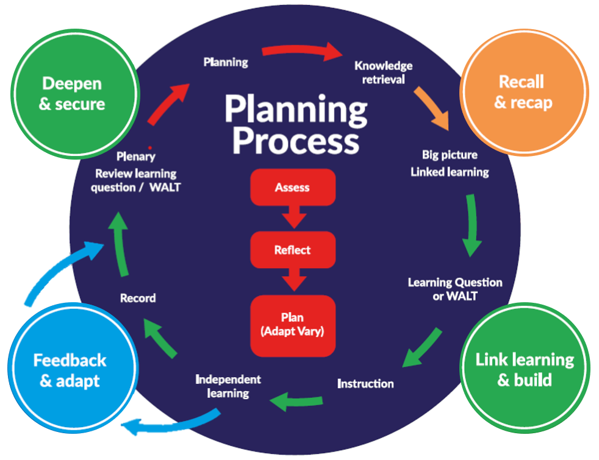
Feedback at TPA sits within the Teaching and Learning Model; a cyclical process that describes both moment-to-moment interaction between teacher and learner, and the process by which teachers plan for, facilitate and evaluate learning in the short and medium term (at a distance from the learner). Feedback here is part of teaching and learning and is the communication of assessment information to the learner. It is the space between what a learner is capable of doing unsupported and what the learner cannot do even with support. This leads to the personalisation of teaching and is, thereby, the sharpest tool in the teacher’s toolbox.

For feedback to be effective, we believe it should be:

Meaningful

The appropriateness and effectiveness of different types of feedback varies by age group, subject and what works best for the pupil and teacher in relation to any particular piece of learning. At TPA, teachers are encouraged to adjust their approach as necessary to make feedback meaningful. They are trusted to incorporate the outcomes from feedback into subsequent planning and teaching. In general, we believe that the most meaningful feedback given to pupils is through discussion with the pupil. This means we favour methods that place the child in conversation with the teacher.

Manageable

Time is required to give and engage with feedback, whether written or verbal. To make the giving and receiving of feedback manageable, feedback is planned-for when learning is planned-for. Deciding, for example, that a piece of learning will be distance-marked prior to a lesson and considering the criteria against which that work will be marked, enables the teacher to share that criteria with the learners and thereby sets the stage for a subsequent, meaningful feedback conversation. Planning time for that conversation, and for pupil engagement with the written feedback given prior to it, ensures feedback is most effective.

To reiterate: time is required to give and engage with feedback. It follows that at TPA, agreed feedback practice is proportionate and considers the frequency and complexity of feedback, considering the cost of practice in relation to the overall workload of teachers.

Motivating

Feedback should help to motivate pupils to progress. This does not always mean in-depth written or verbal comments or being universally positive: sometimes short, challenging comments or the posing of the right question or challenge are most effective. Feedback should provide clarity to bolster knowledge structures and refine skills or should prompt clarifying questions, thinking or action. It should help pupils see a way forward in their learning, making them want to learn more.

Further to this, at TPA we recognise that if the teacher is doing more work than their pupils, this can become a disincentive for pupils to accept challenge and take responsibility for improving their work. Effective feedback motivates pupils by empowering them to learn.

Types of Feedback used across TPA

Verbal feedback

Verbal feedback is when information and guidance are given verbally to a child as to what is incorrect and how to put it right. It is likely to include recognition of achievement.

Written feedback

Written feedback is when information and guidance are given to a child in written form. It is usually written into their exercise book.

Live feedback

This is sitting with a child and talking through a piece or segment of work, celebrating success with meaningful praise and identifying areas for improvement. Live feedback involves engaging with a child’s work, offering clarification or challenge, listening to their response and responding in turn. Importantly, it involves the child making improvements to their work in response to the feedback. Live feedback is essentially verbal feedback but is likely to include some written feedback: the marking up of a passage of writing; the correction of mathematical calculations; the issuing of challenge in the form of a written prompt or question, equation or problem to solve or the use of stamps or other marks such as green highlighting and red pens to provide quick prompts to praise or identify areas for further work.

Distance feedback

Distance feedback is written feedback completed by the teacher, at a distance from the child. It is most effective when pupils are given time to reflect upon and respond to comments written and is made even more effective when complemented by verbal feedback from the teacher after reflection.

Peer feedback

Feedback, verbal or written, live or distant, delivered by a peer, can be particularly effective in motivating pupils to move forward in their learning. The development of effective peer feedback takes time and effort. The allocation of peer partners should reflect the nature of the task and take into consideration pupil’s level of understanding or skill in a particular area. Pupils need to be supported in giving effective feedback through training and suitable materials.

Expectation for quantity and type of feedback and recording

For children in Nursery and Reception

- Every child receives detailed verbal feedback across the areas of learning and development each day, as appropriate.
- Reception Maths work - Each class will have a ‘floor’ book and 3 children each week will have a photo or sample of work recorded in these books. Every child will complete the focus and have assessment notes recorded in the sheet at the back of the book, including next steps where appropriate. Please see EYFS guidance for additional information and examples.
- Reception Literacy books - Each child will have their own book and feedback is given verbally at the time of writing with some visual prompts (such as a stamp) where necessary which children act upon immediately. Summative marking comments should not be extensive, but reflect what cannot be gathered from looking at the work (such as pencil grip, amount of support, effort) and next steps. Please see guidance on EYFS writing books for more details.

For pupils in year-groups 1 - 6

- Teachers judge the quantity, appropriateness and effectiveness of different types of feedback given throughout the course of teaching and learning, taking into account age group, subject and what works best for the child and teacher in relation to any particular piece of learning. As previously stated, at TPA teachers are encouraged to adjust their approach as necessary to make feedback meaningful. They are trusted to incorporate the outcomes from feedback into subsequent planning and teaching. It follows there is no minimum requirement for the amount of written feedback in books.
- Teachers may keep a mark book to record notes during live and distance marking to inform planning and teaching. They are for the teacher alone and will not be monitored. It is expected that during any planning conversation with colleagues or related meeting, such as Pupil Progress Meetings, that these notes support detailed information sharing and thinking.
- When giving written feedback, as part of live feedback or distance feedback, the teacher should use a green highlighter to highlight words or phrases that demonstrate the child has understood the learning intention. Teachers also give written feedback using a red pen to indicate a need for the pupil to take further action to embed learning.
- When responding to their feedback, in all forms, pupils should use a green pen.
- Pupils receive guidance on spelling (key subject vocabulary), grammar and punctuation as part of feedback. Where useful the teacher annotates pupil’s, written work using our feedback symbols (Appendix A). They may do this as part of live or distance feedback. There is no expectation that teachers correct spelling, grammar or punctuation other than that representing the key concepts being learned, unless this is the focus of the lesson.
- While there is no expectation set outside of ensuring feedback is given regularly, it is important that each piece of work in a pupil’s book is acknowledged by the teacher and that the teacher is ‘present’ in each pupil’s books.

Inclusion

- Marking and feedback will be adapted to meet the needs of the learner including EAL (English as an Additional Language) and SEND (Special Educational Needs and Disabilities) which may include reduced language, signs, symbols, use of widget etc.

Expectation for quality of feedback and recording

Feedback focuses on processes rather than outcome and includes the use of specific, meaningful praise rather than generic, generalised praise.

Mistakes are treated differently to errors resulting from misunderstanding. Teachers train pupils to check their work and spot careless mistakes before a teacher looks at it. Remaining mistakes are addressed directly but are not dwelled upon. Quality feedback focusses on addressing misunderstanding.

Misunderstanding is either addressed directly through clarifying comments or indirectly through questions or tasks that prompt reconsideration and lead to clarity. For example:

- The correct way to express that is …
- Use your method to solve the next equation. Does it work?
- Read on two more pages then go back and look again at the explanation you’ve given.

When learners are competent and confident, the role of the person delivering feedback is to support the learners’ self-regulation and encourage them to extend their learning and apply it in different ways. For example:

- How could you add more detail to your explanation?
- Try using an expanded noun-phrase to add more detail to this sentence.
- You’ve completed those accurately, can you use your answers to find a general rule?

In summary, at TPA, we strive to ensure that feedback is:

- Related to the focus of the learning - Learning objective/success criteria
- Accessible - in terms of meaning and vocabulary.
- Achievable and realistic - it should be focused on strategies that can be implemented immediately to help improve learning.
- Specific, accurate and clear - provide specific guidance on how to improve.
- Personalised - to meet the needs of each learner.
- Forward looking and focused on improvement - to be truly formative, the feedback must inform the next steps in the learning process.
- Acted on - there must be time to act on feedback.
- Delivered in a timely manner - ideally during the learning process, or as soon as possible after.
- A two-way process - learners should be involved in the feedback process (discussion, peer, etc…)
- Positive and motivating - nurtures a growth mindset.

Additional adults

It is the responsibility of all adults working with children to provide feedback in line with the marking and feedback policy. Training will be provided on how to effectively implement the policy.

Parent involvement

Parents and carers are made aware of the school’s feedback policy through workshops and information sessions. Letters are sent home to all new parents to inform them of the school’s policy and why we feel it is the best way of ensuring that every pupil makes progress. It is clear for parents to see the impact of our approach as the work in pupil’s books show the progress they have made.

Children’s involvement

Children will be taught about the policy including the meaning of different types of feedback, symbols they will see in their books and the expectation for them to respond and how. Visual aids will be available to support their understanding of the policy in an age appropriate way. Independence will be encouraged to develop an ongoing dialogue of feedback between teachers and children.

Monitoring

Where monitoring of teaching and learning is carried out by the school or Academy, any mention of feedback will be in relation to its impact on pupil learning and progress. There will be no expectation applied as to the quantity or type of feedback in pupil’s books. However, it is important that each piece of work is acknowledged and that the teacher is ‘present’ in each pupil’s books.

Where monitoring is carried out by external bodies, a copy of this policy will be provided and understanding sought and expected. It is expected that leaders and teachers will be able to articulate a robust explanation of this way of working.

APPENDIX 1

TPA Feedback Symbols – to be used during live and distance feedback

- correct/good work

. - incorrect answer

- this bit doesn’t make sense

Sp - spelling mistake

P - missing punctuation

G - grammatical error

^ - missing word

// - new paragraph needed

VF - verbal feedback given

GG - guided group with a teacher/teaching assistant, if applicable

WS - with support

 - indicates a question has been asked by the teacher

